|  |  |
| --- | --- |
| find your Group  Final Project Report | Abstract [Draw your reader in with an engaging abstract. It is typically a short summary of the document. When you’re ready to add your content, just click here and start typing.]  Fangning He, Fei Li, Yunlu Zhou, Zhiyi Wang  INFO6150 38687 Web Design/User Experience Engr SEC 04 - Spring 2017 |

Contents

[Topic of the project: 2](#_Toc480456584)

[Introduction 2](#_Toc480456585)

[Problem definition 2](#_Toc480456586)

[Scope 2](#_Toc480456587)

[Data flow 3](#_Toc480456588)

[Configuration 3](#_Toc480456589)

[Technologies: 3](#_Toc480456590)

[Project Detail Introduction 3](#_Toc480456591)

[Register 3](#_Toc480456592)

[Login 4](#_Toc480456593)

[User Home 4](#_Toc480456594)

[User Personal Page 4](#_Toc480456595)

[Friend Page 5](#_Toc480456596)

[Photo Wall: 5](#_Toc480456597)

[Profile: 7](#_Toc480456598)

[Database and picture stored configuration 8](#_Toc480456599)

## Topic of the project:

## Introduction

This project is a social media website, on which people can build and join friends’ circles where they belong to. Features like pointed posting and timeline story can be used to enhance people’s commitment to their circles and provide a strong notion of community. Ultimate goal of this website

is to practice our web developing skills and dig our own potential to achieve a practical social need.

## Problem definition

Using frond end technique to build a social media website, providing an approach for people to share ideas, exchange cultures and connect with others.

## Scope

* + In scope:
* Register/Login/Logout
* Create profile
* Search a friend/ a circle
* Add/Remove a friend
* Post/delete/comment
  + Out of scope:
* Timeline/Event photo film/animation
* Initiate/Join events/group message
* Tag members on post/link tag to other’s homepage
* Detail of the upcoming events (direction, add to calendar)
* Recommend friends or events

## Data flow

C:\Users\Alex\AppData\Local\Microsoft\Windows\INetCacheContent.Word\Untitled Diagram for final.png

As is shown above in the data flow diagram, clients start from Login page, in which if clients have not registered then register first. After registration, users will come into User Home page. The next level is User Personal page, from there, users can visit their Friends` pages. Both in User Home page and Friend page, there are Post, Photo, Profile and Friend List sections. Particularly, we designed Photo Wall page for Photo section.

## Configuration

## Technologies:

**Front-end:** HTML5，CSS3, Bootstrap, JavaScript, JQuery

**Back-end**: PHP, SQL

## Project Detail Introduction

### Register

### Login

### User Home

### User Personal Page

This page will show up after user click on the personal page icon at navbar. It is the next step after User Home. All the information related to the user is on this page.

#### C:\Users\Alex\AppData\Local\Microsoft\Windows\INetCacheContent.Word\friend_page.pngStructure

Here is the Friend Page website structure. Specifically, the Section Tabs navigate Sections area to display Timeline Here is the Friend Page website structure. Specifically, the Section Tabs navigate Sections area to display Timeline, About, Photos and Friends sections.

e, About, Photos and Friends sections.

#### Tab Content

In the “Section” area of the structure picture. There are four sections, “Timeline”, “About”, “Friends” and “Photos”.

In “Timeline” Section, which are the posts of the users, and structure of each post is as followed,

C:\Users\Alex\AppData\Local\Microsoft\Windows\INetCacheContent.Word\post.png

Here is the panel structure for each user, particularly, we implemented AJAX to partially refresh only the footer part, which I mean is the comment part of the post. Similarly, users can delete a post without refreshing the whole page, but only the post div section.

“About” Section contains the basic information, such as school, work, phone number, of the users. And also, here is a portal for users to update their basic information.

“Friends” Section, just the same with the name, which contains the list of the users` friends. Users can “unfriend” their friends in this section.

“Photos” Section is collecting all the photos that users have uploaded through their posts. There is a subpage called “Photo Wall” to display the photos in a fancier way.

### Friend Page

The whole structures of Friend Page and the subpages are similar to User Page. The differences are as follows:

* There is “Add to Friend” button on a friend page`s cover.
* A user can leave a comment to a friend post, but cannot delete a post.
* A user can add or delete a friend through his or her friend`s “Friends” Section.
* A user cannot update friends` basic information.

### Photo Wall:

In Photo Wall page, a jQuery plugin named masonry is implemented to create a Pinterest-like layout.

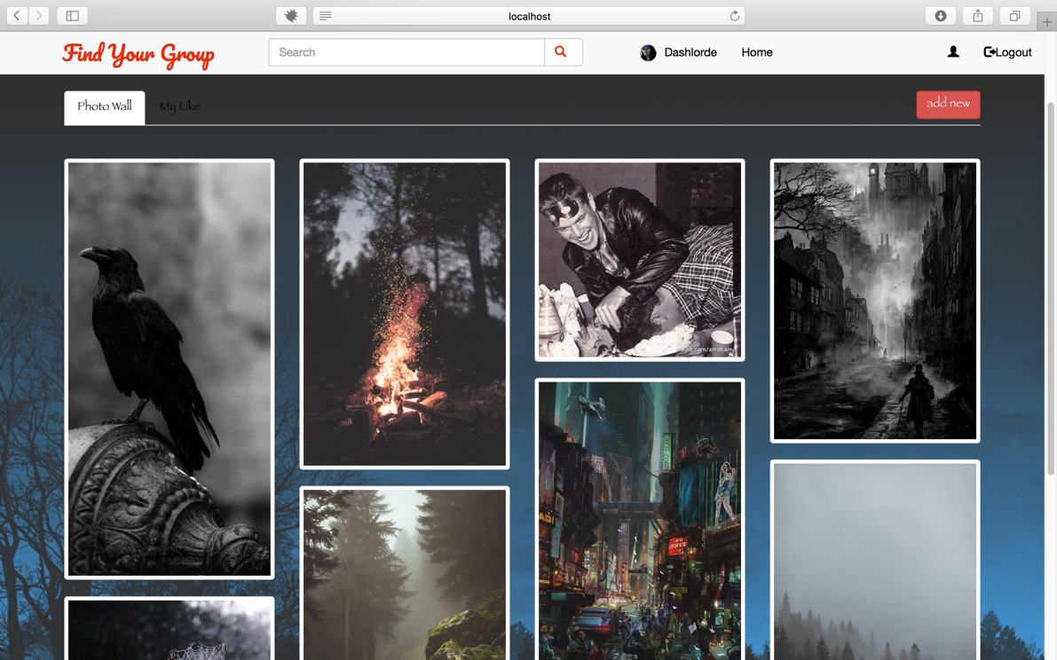

User can upload photo directly in Photo Wall, focus on one of the pictures and delete picture.

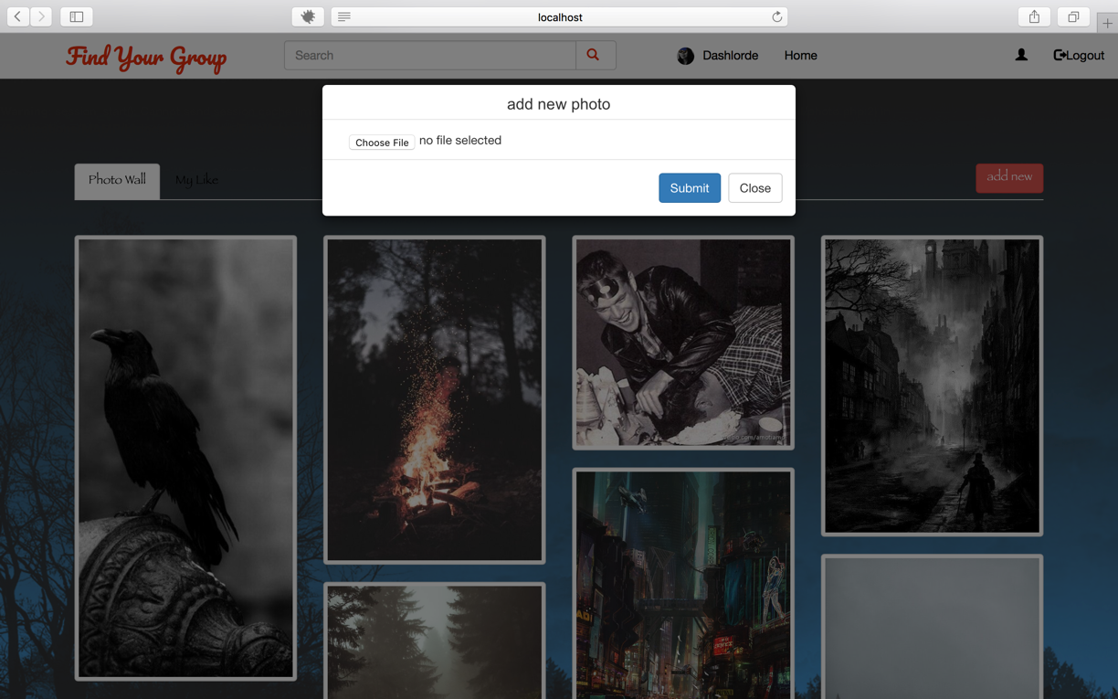

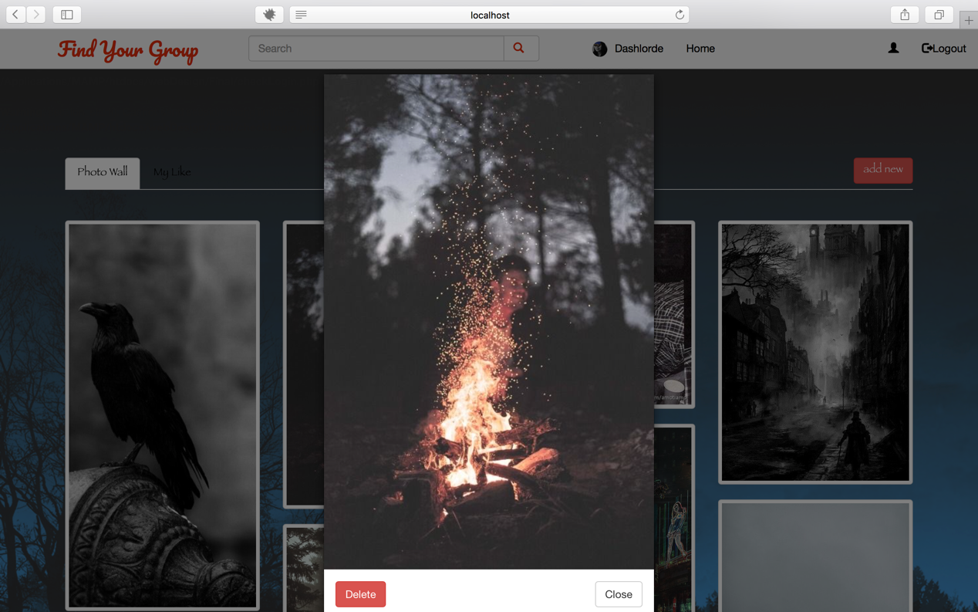

Moreover, user can add photo to like list, and all liked photo will be displayed in My Like tab content. The color of heart icon will change if user add the picture to like list.

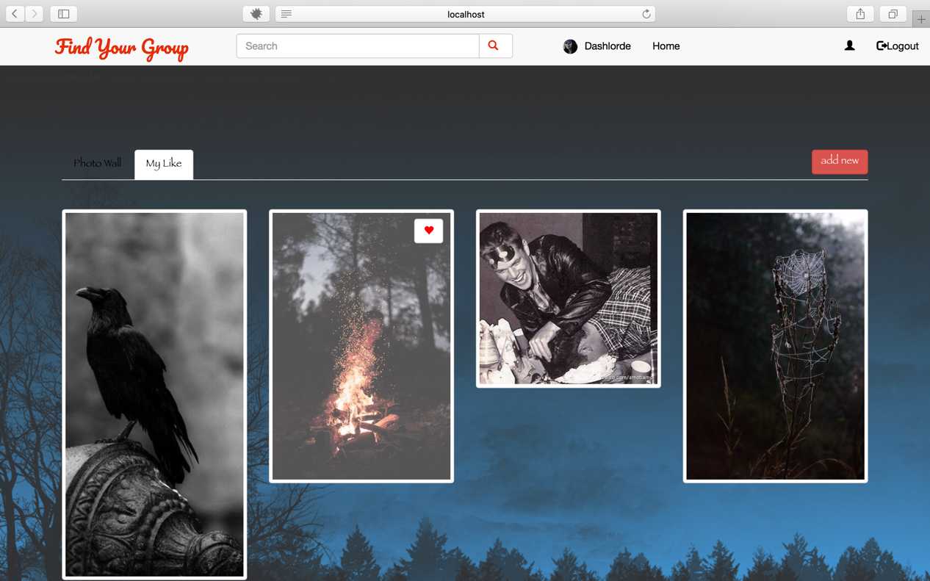

### Profile:

In profile page, a JQuery validation plugin is implemented to validate user’s input. If user input wrong format, error message will be shown immediately. In addition, PHP validation is also configured a more security environment.

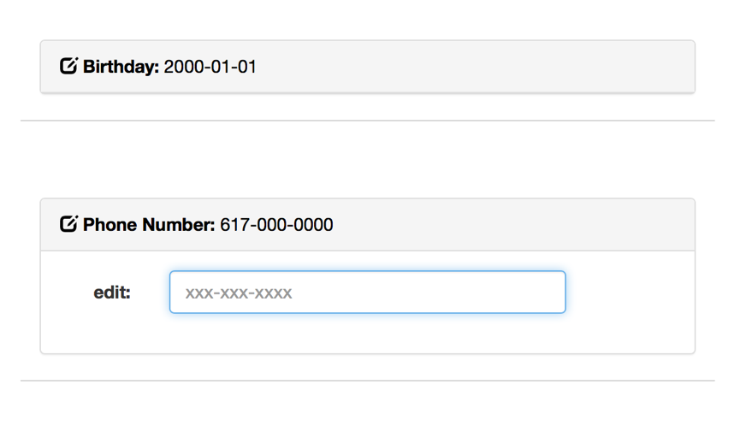

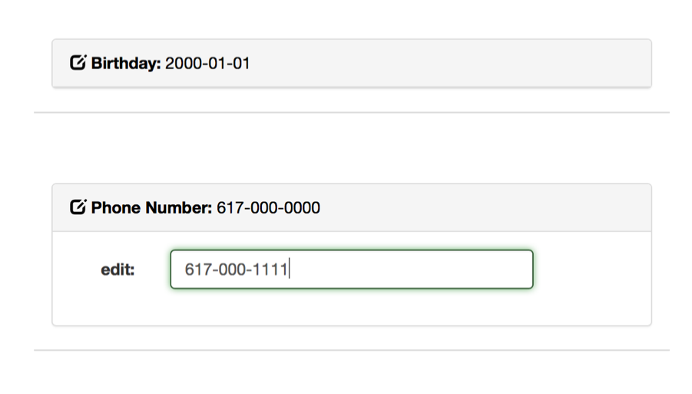

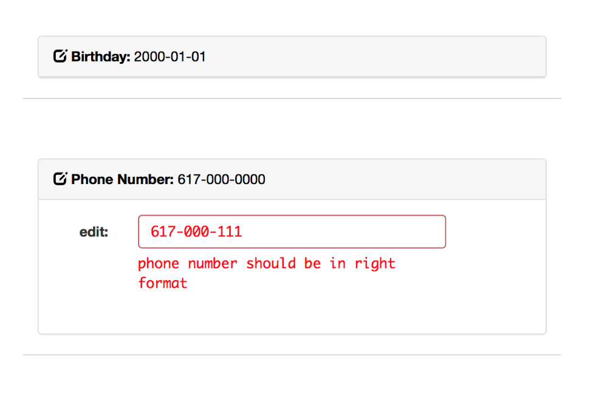

### Database and picture stored configuration

To conveniently synchronized database and pictures in team work. We use Amazon Web Services to create remote database and a bucket for user picture storage. Therefore, this project cannot run directly. Some files need to edit in order to run with local database and local picture storage, or RDS and S3.

The configuration detail is written in readme file in the project root folder.